**User Requirement Specifications**

**for**

**Logic University,**

**Stationery Inventory System**

# 

# 

# 

Table of Contents

1.System Introduction

Project Purpose

Background

Issues Identified

Overview of Scope

Description of Technologies Chosen

Software

Hardware

2. UI Designs

2.1 Department UIs

2.2 Store UIs

2.3 Android Application UIs

3. User Stories

4. Functional Requirements

4.1 System Use Case Diagram

4.2 Activity Diagram

4.2.1 Use Case: Login

4.2.2 Use Case: View Stationery List

4.3 Class Diagram

4.4 Domain Model

5. Non-Functional Requirement

5.1 System Architecture

5.2 System Performance Requirements

5.3 Response Time

5.4 User Volume Table

5.5 Volume of Business Transaction

5.6 Data Volume

5.7 Security Requirements

5.8 Data Access Profile

5.9 Use Case Access Profile

5.10 Reliability Requirements

6 Conclusion

# 1.System Introduction

### Project Purpose

The system aims to bring about the following benefits, such as reducing the amount of manual work needed and to increase the efficiency in which stationery is disbursed to the University Departments. In turn, this will allow stationery store staff more time to attend to other matters instead of being thoroughly focused on maintaining inventory. The system also aims to reduce communication breakdown, by providing a series of notifications that are pushed to different respective users to prompt them for any action required.

### Background

The stationery inventory store is a department of Logic University, which is located at the basement of the main administration building. The store maintains an inventory of stationery commonly (90 category types of stationery) used by all the departments in the University.

The description and stationery codes are recorded in stationery catalogues which are distributed to all departments. Currently all inventory records in the stationery store are maintained manually.

Departments use a physical copy of a Requisition Form to order stationery before seeking the approval by their department heads. This form should reach the Stationery Store by Wednesday and the disbursement is done the following Monday.

### Issues Identified

Key Areas of Concern and Pain Points:

1. Departments are double charged for items due to re-ordering if there are no stocks
2. Departments do not get the full quantity of stationery ordered as stocks are low
3. Department Head cannot appoint a stand-in for approval if he isn’t in office/on leave
4. Store Clerks have to manually go through stock during re-ordering, disbursement
5. Store Clerks have to sometimes deal with last minute collection point changes
6. Store Clerks follow specified re-order levels which might not be enough, no visibility on consumption rates of departments
7. Store Manager is unable to view monthly reports of amount of stationery used for each department over designated time
8. Store Supervisors and Managers are not notified quickly so they can approve the POs which also contributes to stock delay

# 2. UI Designs

### 2.1 Department UIs

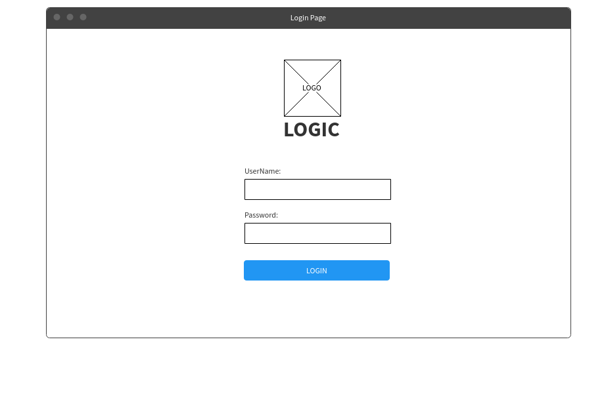

This is the login screen which will be used by the department head and employee.

Department Log In UIs

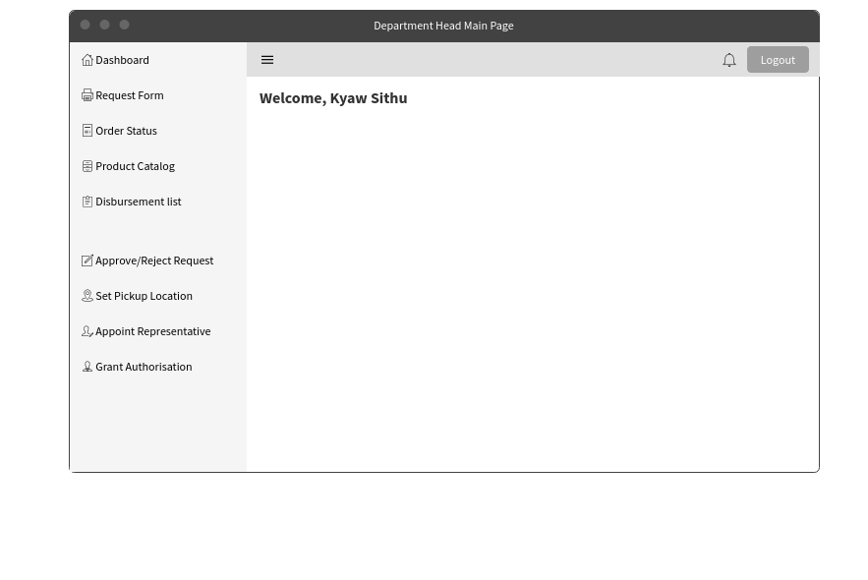

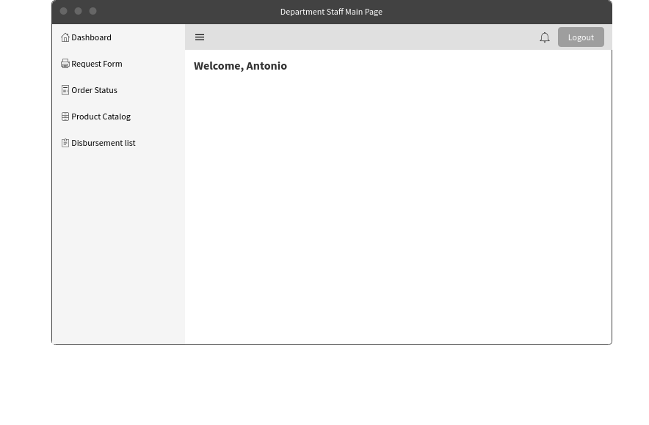

These 2 screens are the main pages after logging in. The one above will be viewed by the department head while the one below will be viewed by the staff.

Stationery Requisition Form

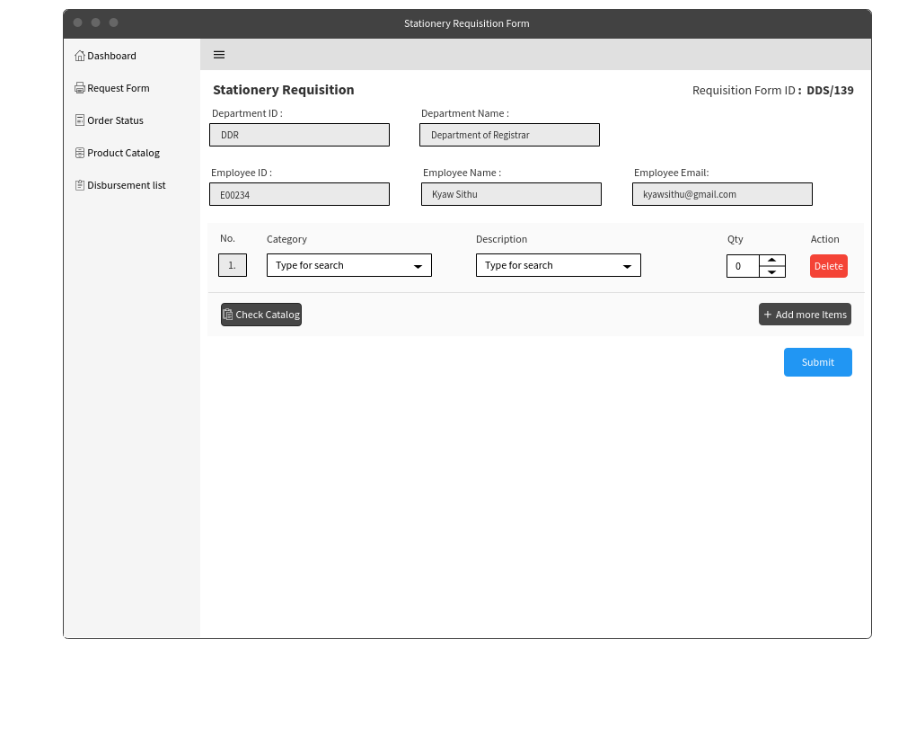

Upon clicking on the request form, the above page will be shown. This page is to submit a request for items that are needed in the department. Users will first select from a Category of item (i.e Pen, Envelope, Paper etc). Once selected, the category’s specific item selection will be presented in a dropdown box. A check catalog button has been included to pop-up a catalogue window in case there is a need to refer to it.

View Order Status

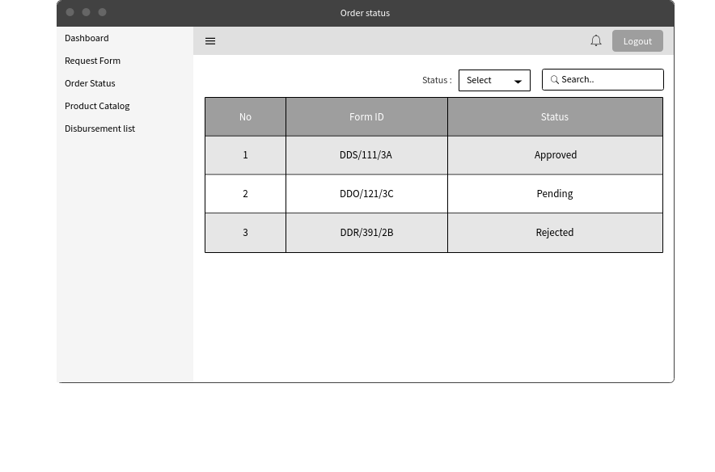

This page is the order status page and can be accessed after clicking on the order status on the left side of the page. Tracking of the form’s status can be done here. Sorting of the status can be done from the drop-down list and searching for specific form can also be done by searching for its unique form ID.

View Order Status - Specific Selection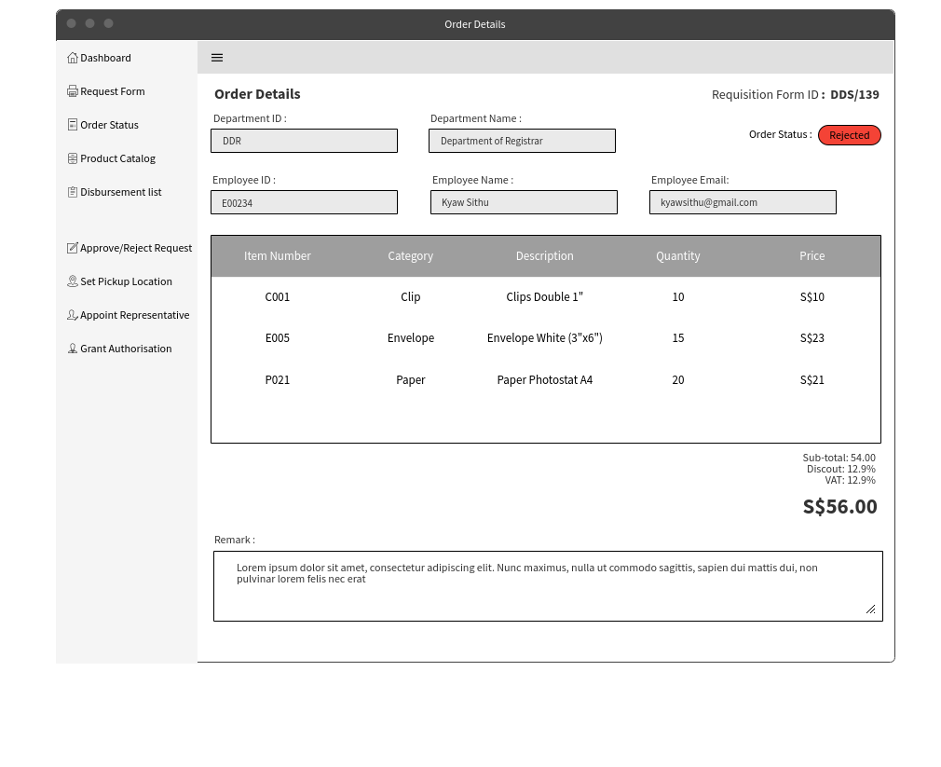

This is the screen after clicking on specific form ID on the order status. The employee can view the detailed version of what they have ordered and the remark provided by the manager is he rejects it.

View Stationery Catalogue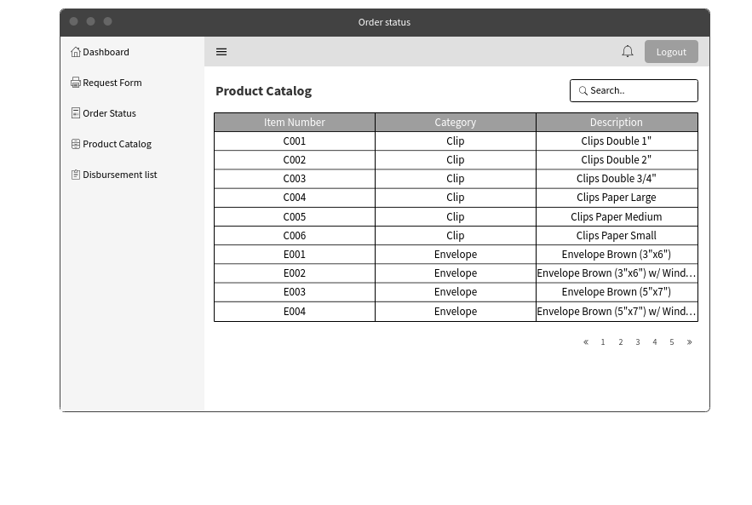

After choosing the product catalogue option on the left side of the screen, a list of stationery that is available to the employees to request. Employees are also able to search for the type of products that they are looking for.

View Disbursement List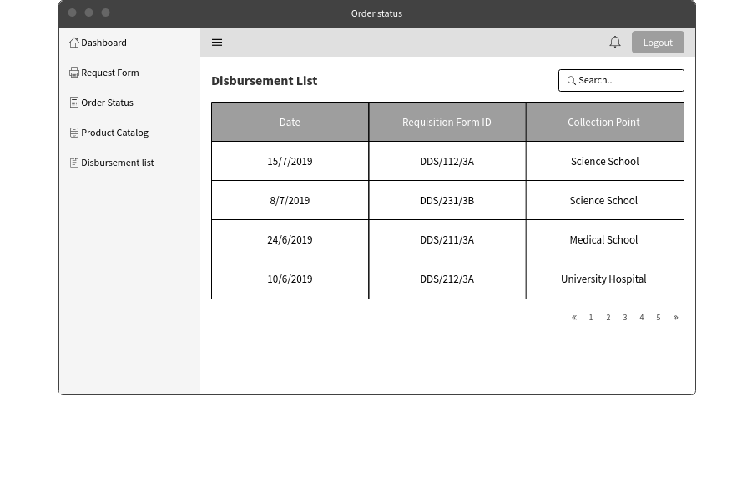

After choosing the disbursement list option on the left side of the screen, a list of disbursement list would be shown. This would allow for the departments to have a copy of the disbursement list that was signed during collection. Having a copy of the disbursement list would help the departments during times of dispute about the stock amount collected or amount to make payment.

Appoint Location (Designated Collection Point)

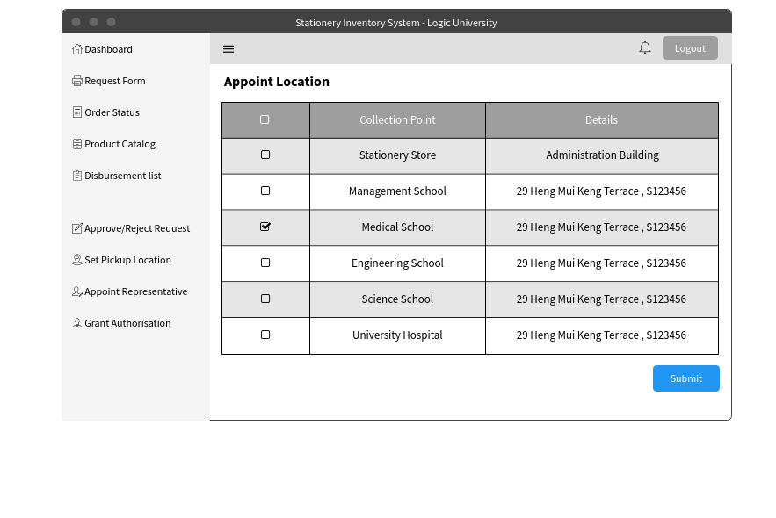

The following screen will be seen and used by the department head. The Department Head will be able to select their department’s chosen location from the listing of available locations. Upon clicking “submit”, it will be set for all stationery orders until the next change.

An additional functionality is added here whereby users are unable to change this location once the day crosses Wednesday 18:00 hours. This is to prevent collection location from changing at the last minute when store clerks are busy collecting stocks and assembling them from disbursement.

Approval/Rejection of Requisition Form

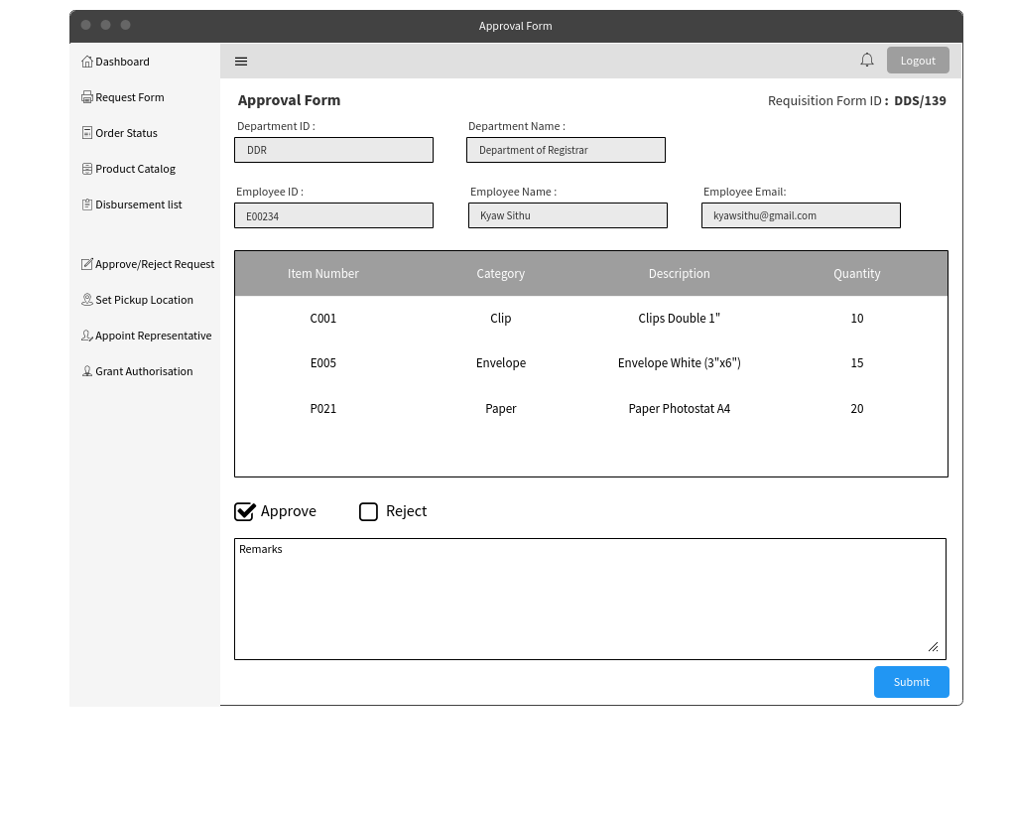

This is the view of the approval and rejection screen. The details of the employee and department would be shown on the top. The details of the stationery that the employee would like to request would be shown below the employee details. Two options of approve or reject would be given so that the decision can be made. The approver would be allowed to give their remarks when they either approve or reject the request. Upon clicking the submit button an email would be sent to the employee and the store clerk to notify them of the approval.

Appointment of Representative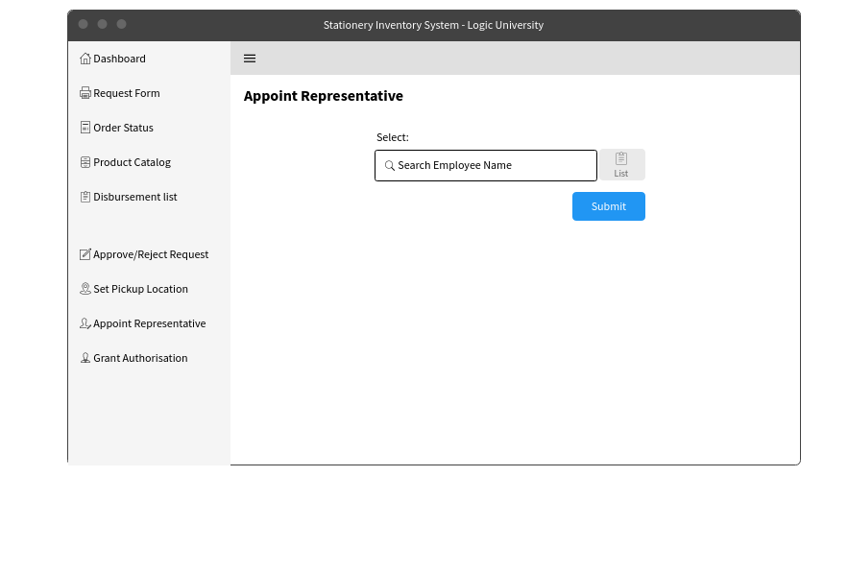

The page above will be shown after clicking on the appointed representative option on the left. An employee name can be entered or clicking the list button will show a list of employee’s name. Upon clicking submit, an email notification will be sent to that specific employee.

Authorizing Department Staff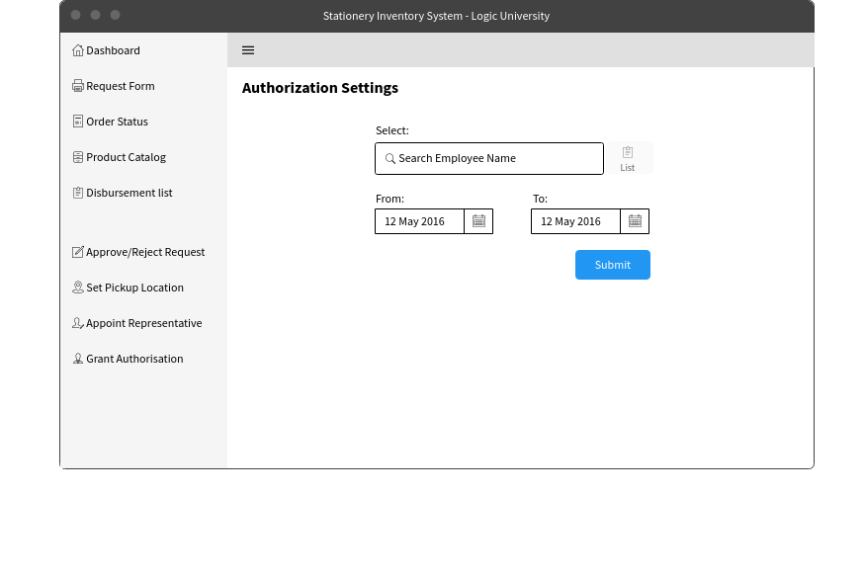

Above shows the authorization page that is accessible by Department Heads. Here, the Department Heads are able to assign approval role to their staff. They will also need to choose a duration of which they want to assign this role to. For easy viewing, an Employee List is included by the side for reference, so that Department Heads are able to view their staff list in the event they require it.

# 

### 2.2 Store UIs

Home Page

Once user is logged in, he will be lead to the homepage, where user will be able to click the menu bar and view list of menu on the side.

### 

### 

Stationery Catalogue For Store

### 

### 

Stationery Catalogue For Store

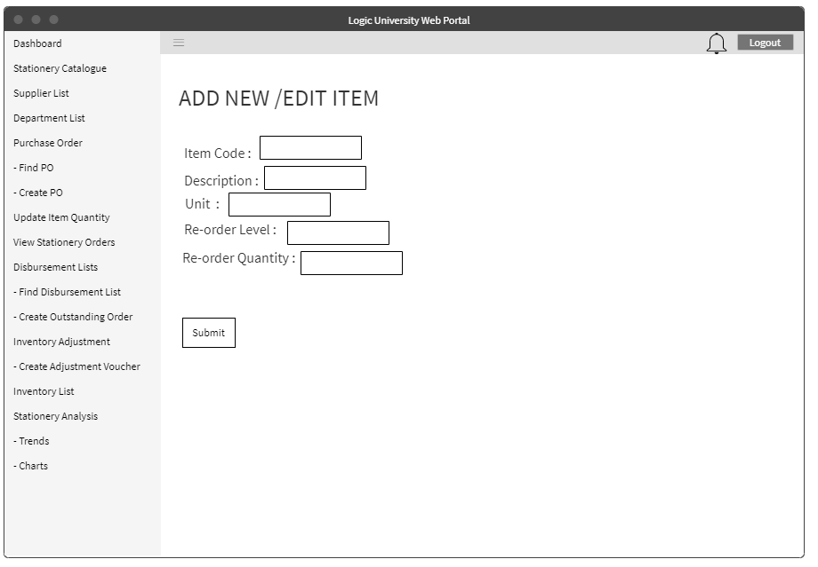Store clerk will be able to refer to the stationery catalogue and make an edit for that particular item.

### 

Stock Card

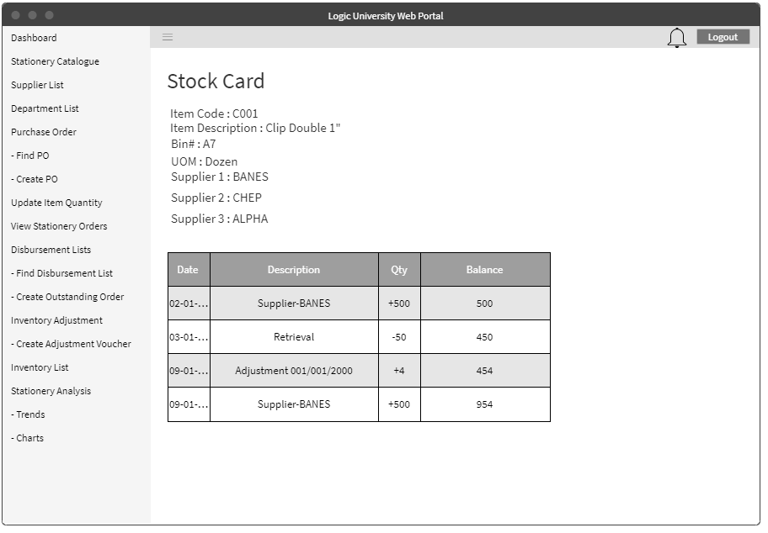In addition, each item will have its own stock card and accessible via the stationery catalogue.

### 

Supplier List for Store Clerk and Store Supervisor

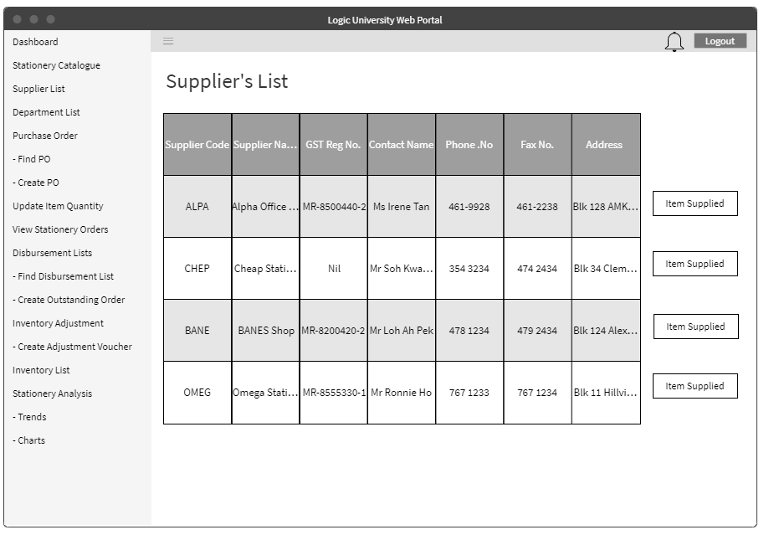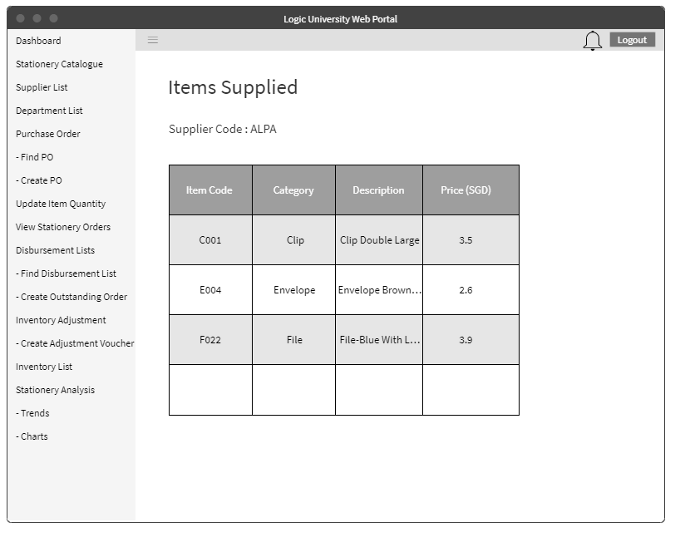

Store Clerk and Store Supervisor will be able to check supplier’s list and the items supplied by that supplier.

Department List for Store Clerk

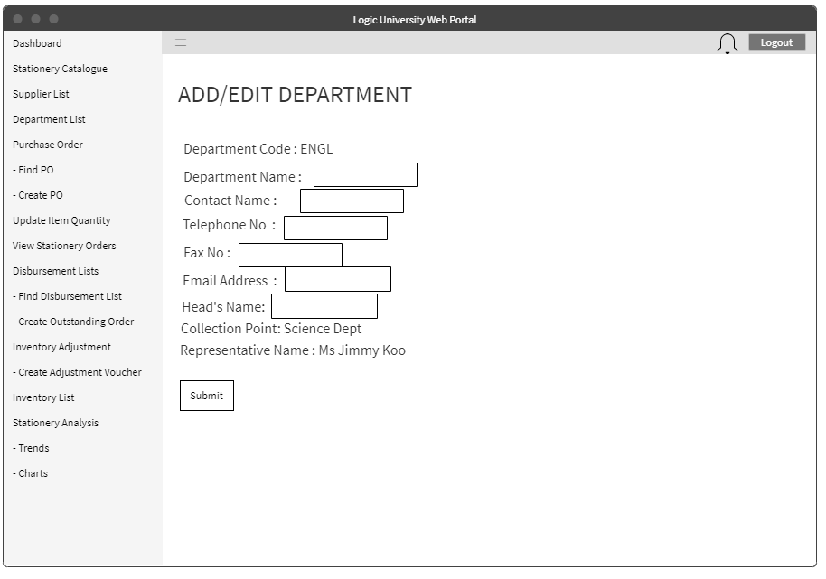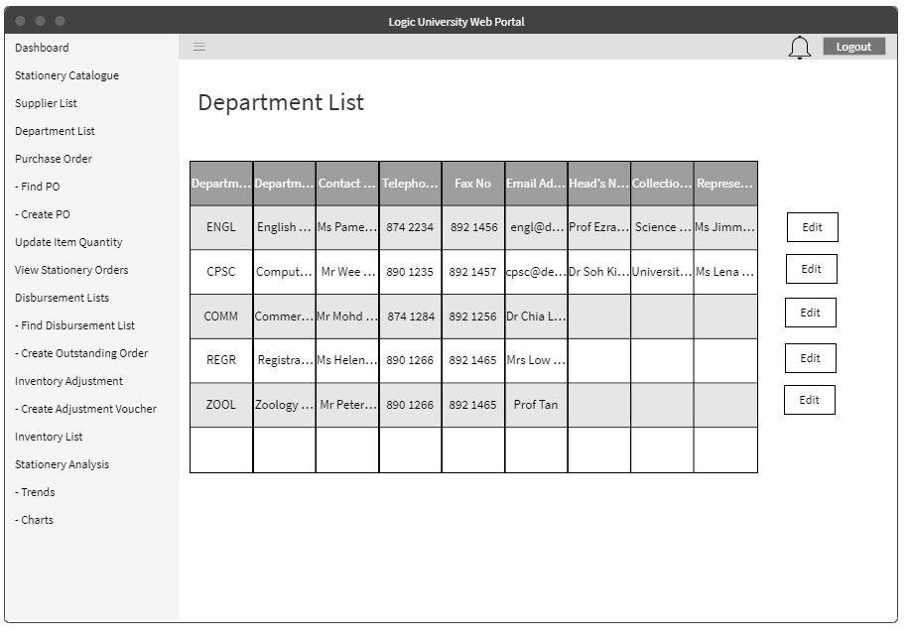

For Store Clerk, he will be able to see the department list and modify some details for that particular department.

Create Purchase Order

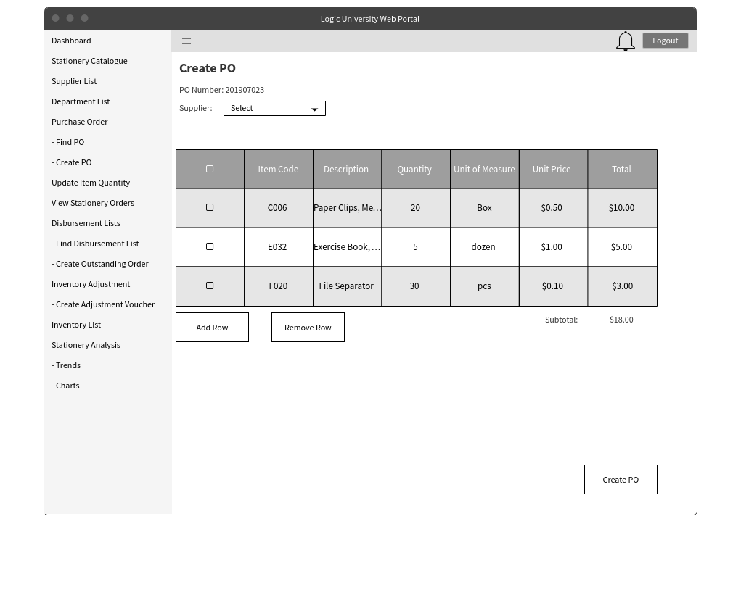

This would be the screen for creating a purchase order. The user would be able to choose the supplier and also the inventory that would be purchased from that supplier. Upon clicking the Create PO, it would be sent to the supervisor or manager for approval.

Purchase Order List

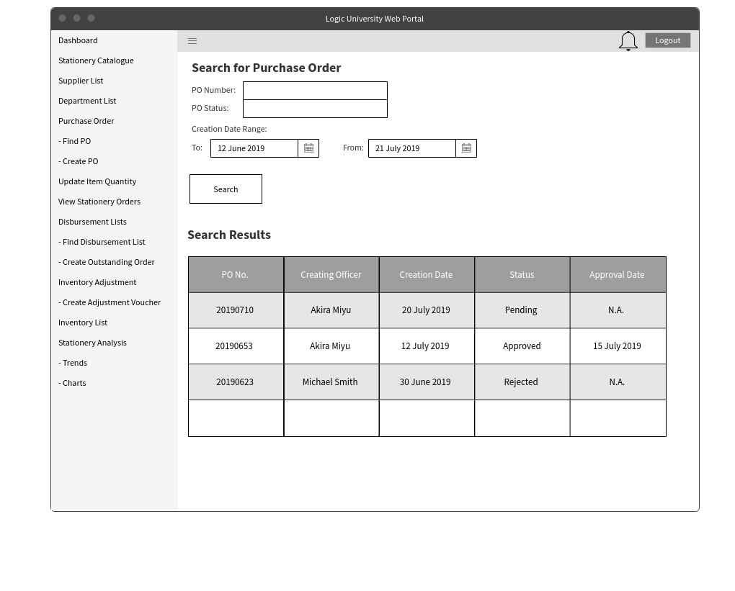

Viewing of the whole purchase order list can be done here. The option to filter the purchase order by either number, status or dates is also available.

View Purchase Order Details

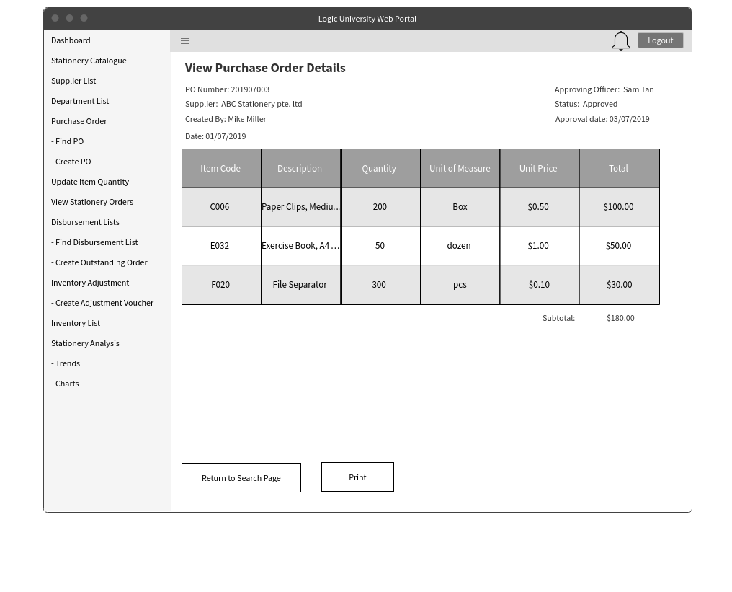

After searching for a particular PO, the detailed view will be shown. It would consist of the item details, price, quantity and the total price of the PO.

List of Disbursement List

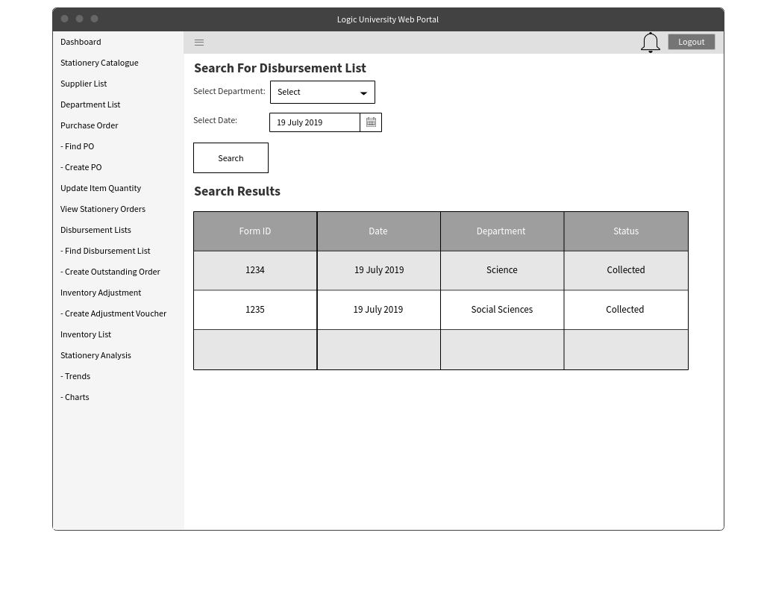

Viewing of all disbursement lists can be done here. The option to filter the purchase order by either department or dates is also available.

### 2.3 Android Application UIs

Below UIs are the android screens for Department Head.

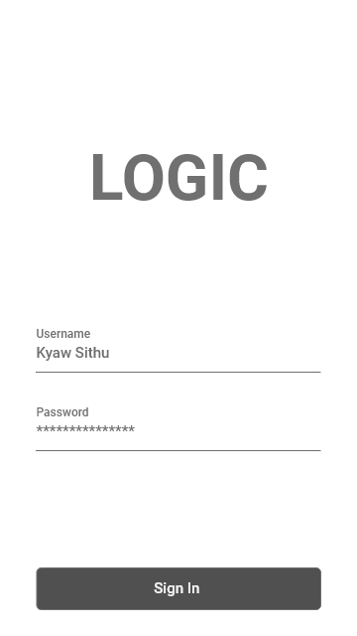

Enter correct username and password to sign in to account.

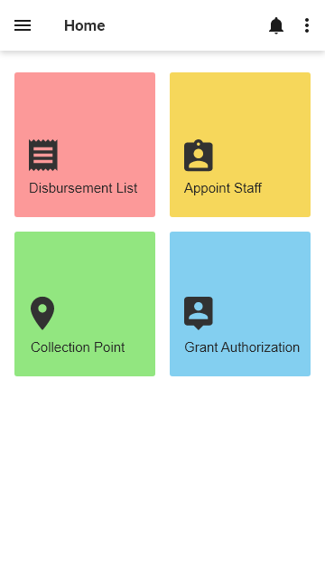

This is the home page for department android application. Clicking the disbursement button will lead you to disbursement list. To appoint representative and collection location, click appoint staff and collection point respectively. Grant Authorization button is to give permission to staff to approve or reject the requisition when the department head is on leave.

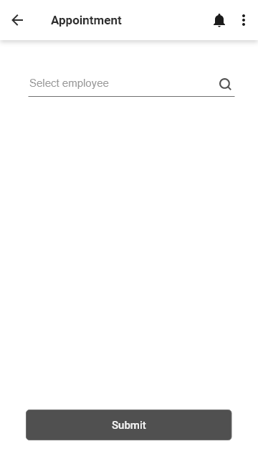

Search for the employee and submit to appoint as department department representative. The search box support with auto-complete and suggestion box.

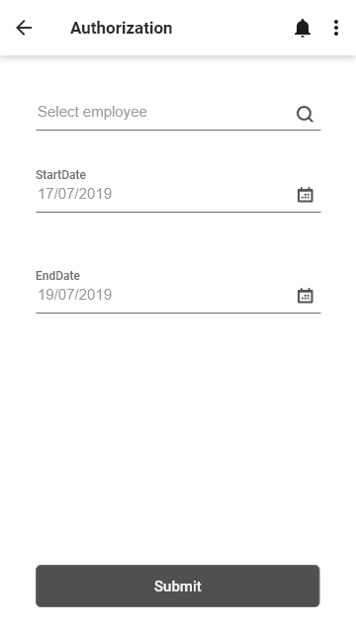

Search employee, select start date and end date to grant permission to that employee.

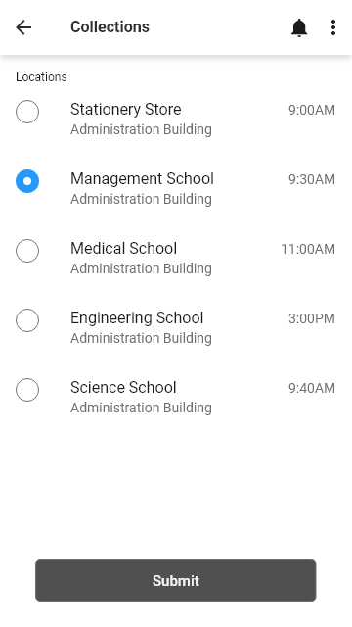

The following list is the collection point locations. Select one to choose which place to collect the ordered items.

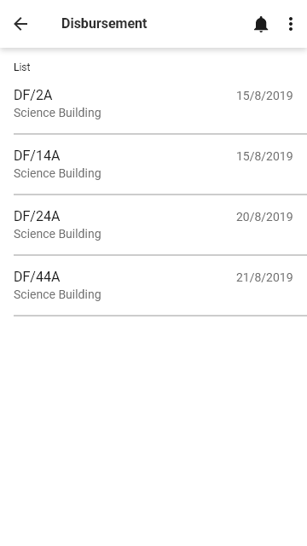

The following list is the disbursement list. Click one to check which items the store be in debt to the department

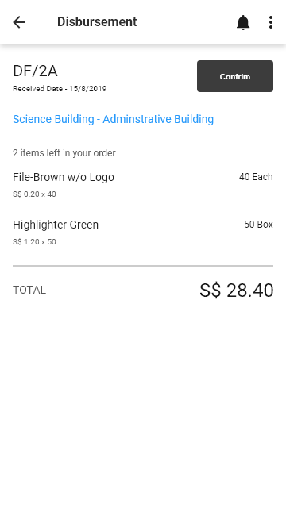

Upon clicking on the specific item on the disbursement list, a detailed information regarding the items not given will be shown.

# 

# 3. User Stories

### 3.1 Department

3.1.1 Department Head

|  |  |
| --- | --- |
| Information from Persona | User Story |
| Able to set collection point, modify and update the department representative. | As a Department head, he would like to be able to maintain the collection point and update the department representative. |
| Unable appoint another employee to do the approval when he on leave or not in office | as a department head, he would like to be able to authorise another employee to do the approval when he is on leave or not in the office |
|  | As a department head, he would like to be able to revoke the authorisation if his leave is cut short |
| He is not notified of any request sent through the requisition form previously | As a department head, he would like to be able to receive a notification when a request is submitted |
| Approval/Rejection of stationary request and update the requester is rejected and update both the requester and store clerk if approved. | As a department head, I would like to be able to approve/ reject request. |
|  | As a department head I would like to update the store clerk and requester on the approved request |
|  | As a department head, I would like to be able to give my feedback on why the request was rejected |

3.1.2 Department Representative/Employee

|  |  |
| --- | --- |
| Information from Persona | User Story |
| Collect stationery from clerk | As a Department Representative, I want to have notification alert or email for inventory collection |
|  | As a Department Representative, I would like to be informed early if there are no stocks, so I don't have to wait at the collection point and waste my time |
| Submit copy of requisition Form | As a Department Representative, sometimes when i order stationery, it takes very long to get approved because my boss does not get notification about it |
|  | As a Department Representative, if I order 10 items, and there are no stocks, at least give me a few, so I can still do some things |
|  | As a Department Representative, sometimes when store gives me less items than requested, I need to request again and then they double charge me |
| Sign off on Disbursement List and keep | As a Department Representative, I would like to have an e-copy so i don't need to keep all these extra documents. |
|  | As a Department Representative, I would like an e-copy so I can also search easily instead of going through hardcopy in cases of dispute |
| Stationery catalogue to order | As a Department Representative, i would like to have an inventory catalogue to order |
| Submit form to the head for approval | As a Department Representative, I would like to be able to submit the form to the head for approval |

### 3.2 Store

3.2.1 Store Clerk

|  |  |
| --- | --- |
| **User** | **User Story** |
| Store Clerk | As a store clerk, I would like to maintain a stationery catalogue so that the departments can place requests easily |
|  | As a store clerk, I would like to know which stationery has low stock so that I can order it from suppliers |
|  | As a store clerk, I would like to raise purchase orders so that I can make orders from suppliers for low-stock items |
|  | As a store clerk, I would like to be notified of the outstanding stationery required that does not fulfill the dept requirement so that I can go back and re-order |
|  | As a store clerk,I would like to generate a Stationary Retrieval form on every Friday which contains total stationary quantity requested and the description from all departments so that i can pick the items from the store and get ready for disbursing them on time. |
|  | As a store clerk, I would like to generate a list of departments and their collection points so that I know where to deliver the stock |
|  | As a store clerk, I would like to be informed of who the dept representative is, so that I can pass the stationery to the correct person |
|  | As a store clerk,I would like to generate a consolidated disbursement list for each department so that I can deliver the correct amount of stationery |
|  | As a store clerk, I would like to be able to view and maintain item's consolidated transaction list (stock card) so that I may tally the physical items held with the quantity displayed in the system |
|  | As a store clerk, I would like to maintain a record of consolidated stationery requests so that I can process the orders correctly and without any delays |
|  | As a store clerk, I would like to get a good estimate on the quantity of items to order so that all departments can always get what they need |
|  | As a store clerk, I would like to be able to notify the department representatives if they have ordered stationery, so that they will be able to collect the stationery they ordered |
|  | As a store clerk,I would like to choose the appropriate supplier for an item so that I can make orders according the purchasing departments guidelines |
|  | As a store clerk, I would like to check if there are any unfulfilled orders to department so that I can prioritize these orders in the subsequent disbursement |

3.2.2 Store Supervisor

|  |  |
| --- | --- |
| **User** | **User Story** |
| Store Supervisor | As a store supervisor, I would like to be able to view stationery consumption data at a glance so that I may know what are the trends in consumption among various departments |
|  | As a store supervisor, I would like to know any discrepancies in the stocks from the clerk so that i can issue a stock adjustment voucher for discrepancy less than $250 and inform manager if the discrepancy is more than $250. |
|  | As a store supervisor, I would like to be notified of any pending purchase order approvals, so that I can process the requests for intime purchase and delivery. |

3.2.3 Store Manager

|  |  |
| --- | --- |
| **User** | **User Story** |
| Manager | As a store manager, I would want to be notified of any stock adjustments greater than $250 so that I can process the request promptly |

# 4. Functional Requirements

### 4.1 System Use Case Diagram

### 4.2 Activity Diagram

### 4.2.1 Use Case: Login

### 4.2.2 Use Case: View Stationery List

### 4.3 Class Diagram

### 4.4 Domain Model

# 

# 5. Non-Functional Requirement

### 5.1 System Architecture

The Logic University campus is linked by a local area network. Each employee is provided with a PC, which they can use for accessing email and any other work-related purposes. A printer will be shared among every 4 to 5 employees. There is also a printer set-up in the Stationery Store Department. All the servers, including printer server and database server, are located in a secured computer room within the campus.

### 5.2 System Performance Requirements

The web application system will be available during office hours (9am - 5pm Mon to Fri; 9am - 12pm Sat). The mobile application would be available 24 hours a day, 7 days a week.

### 5.3 Response Time

The system would take roughly 2 seconds to navigate between screens.

### 5.4 User Volume Table

|  |  |  |
| --- | --- | --- |
| User Group | Country/Location/Count | Remarks |
| Department Head | Singapore/Department/1 | Department head is stationed at their respective department and needs to use the system regularly. |
| Department Staff | Singapore/Department/49 | Department staff is stationed at their respective department and is one of the most frequent users of the system. |
| Store Clerk | Singapore/Stationery Store/3 | Store Clerk is stationed at the stationery store and is the most frequent user of the system. |
| Store Supervisor | Singapore/Stationery Store/1 | Store Supervisor is stationed at the stationery store and needs to use the system regularly. |
| Store Manager | Singapore/Stationery Store/1 | Store Manager is stationed at the stationery store and needs to use the system regularly. |

### 5.5 Volume of Business Transaction

|  |  |  |  |  |
| --- | --- | --- | --- | --- |
| Business Transaction | Business Criticality | No.of Users | Transaction Information | Concurrently Important Activities |
| Login to System | Critical | 500 | 1/day/staff |  |
| Create Requisition Form | Critical | 500 | 1/week/staff |  |
| Appoint Department Representative | Moderate | 10 | 1/week/department head |  |
| Appoint Substitute Approver | Low | 10 | 1/week/department head |  |
| Appoint Collection Point | Moderate | 10 | 1/week/department head |  |
| Approve Requisition Form | Critical | 10 | 1/week/department head |  |
| Maintain Stationery Catalogue | Low | 5 | 1/year/store staff |  |
| Maintain Supplier List | Low | 5 | 1/year/store staff |  |
| Maintain Adjustment Voucher | Moderate | 5 | 1/month/store staff |  |
| Maintain Inventory Status Report | Moderate | 5 | 1/month/store staff |  |
| Approve Adjustment Request | Moderate | 2 | 1/month/store staff |  |
| Create PO | Critical | 3 | 1/week/store clerk |  |
| Approve PO | Critical | 1 | 1/week/store supervisor |  |
| Search Disbursement List | Moderate | 500 | 1/month/staff |  |
| Generate Disbursement List | Critical | 5 | 1/week/store staff |  |
| Maintain Inventory Retrieval List | Critical | 5 | 1/week/store staff |  |
| Maintain Consolidated Request Form | Critical | 5 | 1/week/store staff |  |

### 

### 5.6 Data Volume

|  |  |  |  |
| --- | --- | --- | --- |
| Business Entity Class | Source Document | Retention Period | Target Volume |
| Stationery List | Product Information | 2 years | Logic University has a catalogue of 90 products and each product has its own product information. Assuming 10 products are brought in each year,  Current Products: 90  2 year: 90 + 10 x 2 = 110 |
| Employee List | Employee Information | 5 years | The increase in the number of employees would be up to the discretion of the university administration. |
| Inventory List | Available Stock Information | 5 years | Assuming that 80% of stationeries is replenished every year  Current Products: 90  Total replenish in a year: 90 x 80% = 72 |
| Disbursement List | Stock Issued Information | 5 years | Assuming that there is at least 1 disbursement list per department a week  Current Year = 52 x 10 x 1 = 520  5 yrs: 520 x 5 = 2,600 |
| Requisition Form List | Order Information | 5 years | Assuming that 10% of employee request for stationery per week  Current year : 52 x 500 x 10% = 2,600  5 yrs: 2600 x 5 = 13,000 |
| Collection Point List | Collection Point Information | 1 year | There would not be any changes to the collection. |
| Adjustment Voucher List | Adjustment Information | 5 years | Assuming that there is at least adjustment voucher a month  Current Year = 12 x 1 = 12  5 yrs: 12 x 5 = 60 |
| Consolidated Order List | Consolidated Order Information | 5 years | Since there is an order for the stationery every week, this would mean that there would be a consolidated order list every week as well.  Assuming every year: 52 weeks  5 years: 52 x 5 = 260 |
| Supplier List | Supplier Information | 3 years | Since the suppliers has to go through a tender process and there is a fixed amount of suppliers that would be awarded the tender, there would be no increase in the number of suppliers. |
| Department List | Department Information | 3 years | There would be no increase in the number of departments. |

### 5.7 Security Requirements

5.7.1 Mobile Application

For mobile application, it is only to be used by the department head. This would mean that only department head would have full access to maintain the application.

5.7.2 Web Application

|  |  |  |  |  |  |
| --- | --- | --- | --- | --- | --- |
| Data (Entity Class) / User Role (Actor) | Department Head | Department Staff | Store Clerk | Store Supervisor | Store Manager |
| Login to System | R,U | R,U | R,U | R,U | R,U |
| Create Requisition Form | C,R,U,D | C,R,U,D | - | - | - |
| Appoint Department Representative | R,U | - | - | - | - |
| Appoint Substitute Approver | R,U | - | - | - | - |
| Appoint Collection Point | R,U | - | - | - | - |
| Approve Requisition Form | R,U | - | - | - | - |
| Maintain Stationery Catalogue | R | R | R,U | R,U | C,R,U,D |
| Maintain Supplier List | - | - | R | R | C,R,U,D |
| Maintain Adjustment Voucher | - | - | C,R,U,D | R,U | R,U |
| Maintain Low Status Stock Report | - | - | R,U | - | - |
| Maintain Department List | - | - | R,U | - | - |
| Check Stock Card | - | - | R | - | - |
| Maintain Inventory Status Report | - | - | R,U | - | - |
| Approve Adjustment Request | - | - | - | R,U | R,U |
| Generate Stationery Requisition Trends | - | - | - | R,U | - |
| Generate Department Requisition Trends | - | - | - | R,U | - |
| Create PO | - | - | C,R,U,D | - | - |
| Search PO | - | - | R,U,D | - | - |
| Approve PO | - | - | - | R,U | R,U |
| Maintain Disbursement List | - | - | C,R,U,D | - | - |
| Search Disbursement List | R | R | R | R | R |
| Generate Disbursement List | - | - | C,R,U,D | - | - |
| Maintain Inventory Retrieval List | - | - | C,R,U,D | - | - |
| Search Inventory Retrieval List | - | - | R,U,D | - | - |
| Generate Inventory Retrieval | - | - | R | - | - |
| Maintain Consolidated Request Form | - | - | C,R,U,D | - | - |

C = Create, R = Read, U = Update, D = Delete

### 

# 

# 6 Conclusion